Visual Design Quiz: Reading for Information
Name: ______________________________
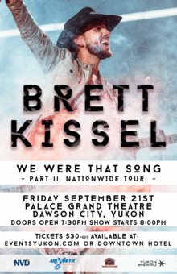
- Who is playing at this concert?

- Who is the target audience?

- What is the name of this event and what is happening at it?

- Where does the concert take place?

- When is the concert?

- How is the event being sponsored?

