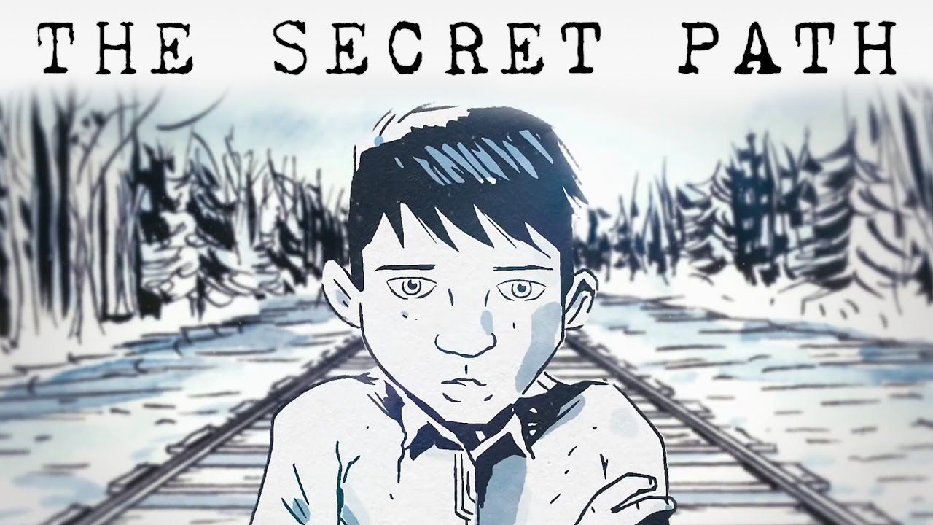

AND
“Wenjack” by Joseph Boyden

Student Workbook
Name: ____________

Lesson 2
Acknowledgement and Truth
Excerpt from “The Lonely Death of Charlie Wenjack”, Mclean's, 1967
CHARLIE WENJACK would have been 13 years old on January 19, and it’s possible that during his short and disturbed life someone may have taken a snapshot of him — one of those laughing, open-faced, blurred little pictures one so often sees of children. But if a snap was taken, nobody knows where it is now. There are five police pictures of Charlie, though. They are large 8-by-10 prints, grey and underexposed, showing the thin, crumpled little body of a 12-year-old boy with a sharp-featured face. He is lying on his back and his thin cotton clothing is obviously soaked. His feet, encased in ankle-high leather boots, are oddly turned inward. In one of the photographs an Ontario Provincial Police sergeant is pointing down at Charlie’s body, where it lies beside the CNR track. It is the exact spot where on the night of October 22 Charlie collapsed and died from exposure and hunger . . . just four-and-a-half feet from the trains that carry the white world by in warm and well-fed comfort. When they found Charlie he didn’t have any identification. All they got out of his pockets was a little glass jar with a screw top. Inside were half a dozen wooden matches. They were all dry. And that’s all he had.
Charlie Wenjack was an Ojibway Indian attending Cecilia Jeffrey Indian Residential School in Kenora, Ont. He became lonely and ran away. He died trying to walk 400 miles home to his father, who lives and works on an isolated reservation in northern Ontario. It is unlikely that Charlie ever understood why he had to go to school and why it had to be such a long way from home. It is even doubtful if his father really understood either.
It’s not so unusual that Indian children run away from the residential schools they are sent to. They do it all the time, and they lose their toes and their fingers to frostbite. Sometimes they lose a leg or an arm trying to climb aboard freight trains. Occasionally, one of them dies. And perhaps because they are Indians, no one seems to care very much. So this, then, is the story of how a little boy met a terrible and lonely death, of the handful of people who became involved, and of a town that hardly noticed.
Even before Charlie ran away he was already running hard just to keep pace with the bewildering white world he had suddenly been thrust into. He didn’t start school until he was nine. The village he came from, Ogoki Post on the Martin Falls reservation, didn’t have a day school. Charlie arrived at the Cecilia Jeffrey School, which is run by the Presbyterian Church and paid for by the federal government, in the fall of 1963. Some 150 Indian children live at the school but are integrated into the local school system. Consequently, Cecilia Jeffrey is, for 10 months in the year, really nothing more than an enormous dormitory. And Charlie, who understood hardly any English, spent the first two years in grade one. He spent last year in what is called a junior opportunity class. That means he was a slow learner and had to be given special instruction in English and arithmetic. This fall he wasn't quite good enough to go back into the grade system, so he was placed in what is called a senior opportunity class. But there was nothing stupid about Charlie. His principal of last year, Velda MacMillan, believed she got to know him well. "The thing we remember most about him was his sense of humor. If the teacher in the class made a joke, a play on words, he was always the first to catch on."
Charlie wasn't a strong boy. In fact, he was thin and sickly. He carried an enormous, livid scar that ran in a loop from high on his right chest, down and up over his back. It meant that in early childhood his chest had been opened. Nobody knows exactly when. "Indian children's early medical records are practically impossible to track down," explains Kenora’s public-health doctor, P. F. Playfair. The postmortem that was later performed on Charlie by Dr. Peter Pan. of Kenora, showed that his lungs were infected at the time of his death.
Read “Charlie Wenjack” by Willie Dunn
Walk on, little Charlie
Walk on through the snow.
Heading down the railway line,
Trying to make it home.
Well, he's made it forty miles,
Six hundred left to go.
It's a long old lonesome journey,
Shufflin' through the snow.

He's lonesome and he's hungry,
It's been a time since last he ate,
And as the night grows bolder,
He wonders at his fate.
For his legs are wracked with pain
As he staggers through the night.
And he sees through his troubled eyes,
That his hands are turning white.

Lonely as a single star,
In the skies above,
His father in a mining camp,
His mother in the ground,
And he's looking for his dad,
And he's looking out for love,
Just a lost little boy by the railroad track
Heading homeward bound.

Is that the great Wendigo
Come to look upon my face?
And are the skies exploding
Down the misty aisles of space?
Who's that coming down the track,
Walking up to me?
Her arms outstretched and waiting,
Waiting just for me.
Walk on, little Charlie,
Walk on through the snow.
Moving down the railway line,
Try to make it home.
And he's made it forty miles,
Six hundred left to go.
It's a long old lonesome journey,
Shufflin' through the snow.

- Willie Dunn

Think about which form or the story you preferred. Why did you make this choice? Think about your choice when you have the opportunity to represent your own stories. You can choose to tell them through poetry, art, song, narrative writing and more.

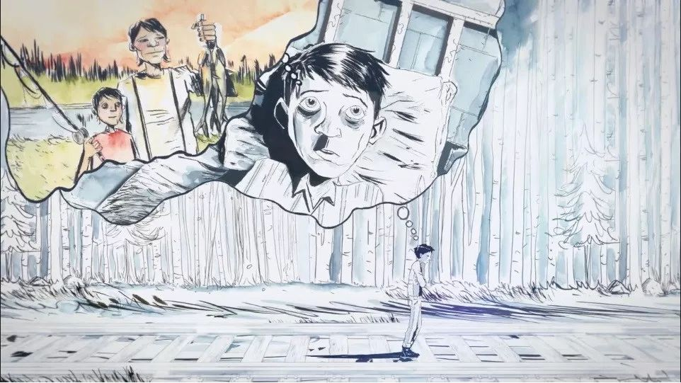
Journal Entry Lesson 2: Truth
After reading Wenjack and watching “I will not be Struck” by Gord Downie, write a journal response.
What are some feelings that Chanie is expressing? What emotions does this make you feel? Write a reflection about anything you learned today. ________________________________________________________________________________________________________________________________________________________________________________________________________________________________________________________________________________________________________________________________________________________________________________________________________________________________________________________________________________ ________________________________________________________________________________________________________________________________________________________________________________________________________________________________________________________________________________________________________________________________________________________________________________________________________________________________________________________________________________________________________________________________________________________________________________________________________________________________________________________________________________________________________________________ ____________________________________________________________________________________________________________________________________________________________________________________________________________________________________________________________________________________________________________________________________________________________________________________________________________________________________________________________________________________________________________________________________________________________________________________________________Lesson 3
Atonement and Reconciliation
What defines Canada’s Identity? | What makes Canada different from other countries?
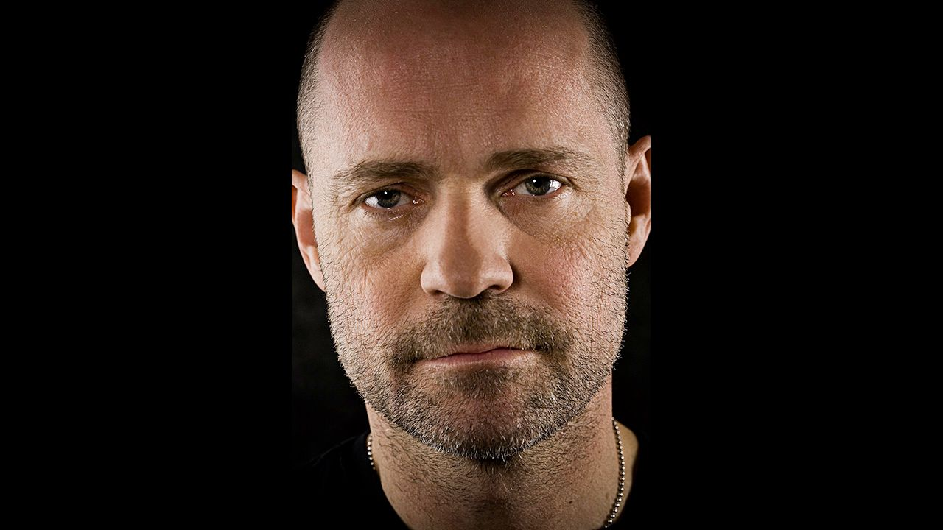

Define Reconciliation:
____________________________________________________________________________________________________________________

Define Atonement:
____________________________________________________________________________________________________________________

What did Gord do to contribute to reconciliation? How does his legacy live on? | What could YOU do to contribute to reconciliation?
Journal Entry Lesson 3: Reconciliation
________________________________________________________________________________________________________________________________________________________________________________________________________________________________________________________________________________________________________________________________________________________________________________________________________________________________________________________________________________ ________________________________________________________________________________________________________________________________________________________________________________________________________________________________________________________________________________________________________________________________________________________________________________________________________________________________________________________________________________________________________________________________________________________________________________________________________________________________________________________________________________________________________________________ ____________________________________________________________________________________________________________________________________________________________________________________________________________________________________________________________________________________________________________________________________________________________
Lesson 4
Action and Commitment
How important to you is that people apologize to you when you’ve been wronged? Why?
__________________________________________________________________________________________________________________________________________________________________________________________________________________________________________________________________________________________________
After watching the Statement of Apology:
How did the Statement of Apology make you feel? Was the apology sincere? __________________________________________________________________________________________________________________________________________________________________________________________________________________________________________________________________________________________________
What are some of the Calls to Action?

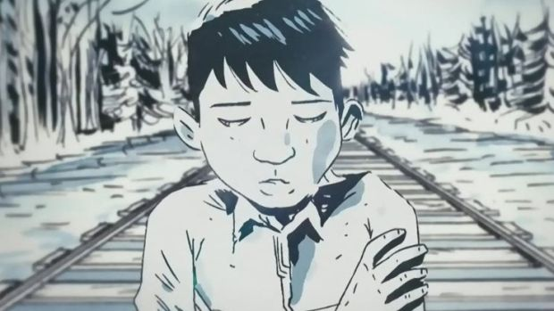
What are some actions you and your classmates could take?
Actions I can take | Actions my class can take

Journal Entry Lesson 4: Action
________________________________________________________________________________________________________________________________________________________________________________________________________________________________________________________________________________________________________________________________________________________________________________________________________________________________________________________________________________ ________________________________________________________________________________________________________________________________________________________________________________________________________________________________________________________________________________________________________________________________________________________________________________________________________________________________________________________________________________________________________________________________________________________________________________________________________________________________________________________________________________________________________________________ __________________________________________________________________________________________________________________________________________________________________________________________________________________________________________________________________________________________________
Final Projects for Wenjack by Joseph Boyden

Symbolism:
- After reading Wenjack by Joseph Boyden, you will choose one of the animals from a chapter and create a replica of it. You can choose any form of representation you want (digital, painting, drawing, DIY stuffed animal, sculpture…)
- Explain what the symbol means (Write this down or if you are creating a digital resource you can record your voice)
- Explain why you think Joseph Boyden chose this animal for the chapter. This means you will have to pull evidence from the text and your own life experiences to support your opinion. USE YOUR ROUGH NOTES
- Find a poem, song or other form of art that also includes this animal and include it with your project.
- Do the animals represent the same thing or not? Explain in a well-developed paragraph.
- All rough notes will be submitted as part of your assessment
Curricular competency | Comment
Recognize how literary elements shape meaning (symbolism)
Construct connections between self, text and world (connecting to other text)
Exchange ideas to build understanding
Think critically, creatively and reflectively
Use writing and design process to create text (rough notes)

Animal | Symbolic meaning | Why Boyden chose this animal for the chapter
Suckerfish
Crow
Hummingbird
Owl
Mouse Skull
Pike
Spider
Wood Tick
Beaver
Snow Goose
Rabbit
Lynx

Radio News Broadcast: Group Project (2-3 people using Garage Band)
- Choose a section of the story and write a news story. BE SPECIFIC THIS IS NOT A SUMMARY
- Follow the inverted pyramid structure.
- Remember to include quotes and other supporting details from from people who might have been there or professionals who could comment on the situation.
- Choose one song that connects to the story you tell. Think of one word that represents that chapter, then find a song that touches on the same topic. You will need to be ready to explain why you chose this song.
- Include an advertisement about how people can promote reconciliation.
- All rough notes will be submitted as part of your assessment
Areas of Assessment:
Curricular Competency | Comment
Recognize a range of text structures (inverted pyramid, structure of a radio show)
Refine text to improve clarity and impact (editing draft of script and applying effective strategies to your voice when recording)
Respond to text-personal, creative, critical (song choice, reconciliation ad, news story)
Use features for audience, purpose, message (using appropriate language and tone for the audience of your broadcast)

