Medieval Life and Custom

The Manor (Pg. 47 & 48)
Define the following
Fief: ______________________________________________________________________________________________________________

Bailiff:
______________________________________________________________________________________________________________
Fallow:
______________________________________________________________________________________________________________

Sustainable:
______________________________________________________________________________________________________________
Label the following on the diagram of a manor
Mill Church woodland pasture blacksmith
tannery demesne river thatched roof

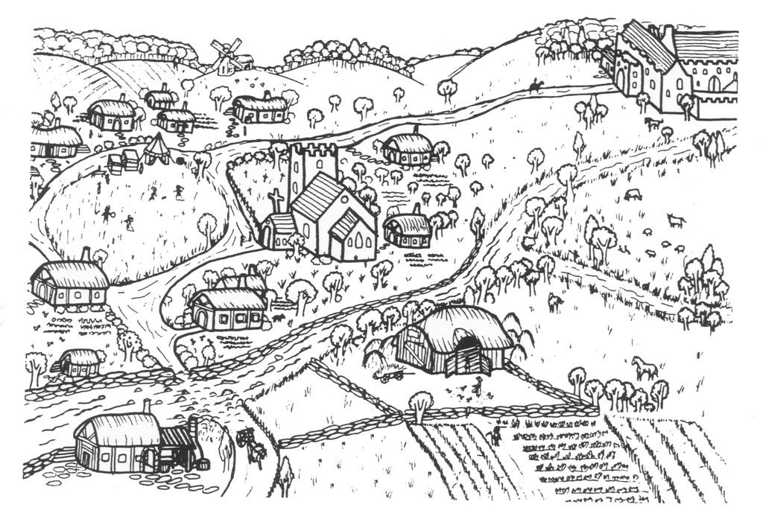
Ordinary People (Pg. 50 & 51)
List 5 facts about serfs and/or freeholders.

Describe 4 features of a village home. Draw a picture if it will help you remember.

Work
MEN | WOMEN

Piers the Ploughman
List the foods that Piers have and doesn’t have
Food he has | Food he doesn’t have
Lord and the Lady of the Manor (Pg. 52 & 53)

Describe 4 features of a manor. Draw a picture if it will help you remember.

Privileges
Nobles lived very well. They often owned rare possessions, which they kept as status symbols. Falcons, horses, fine furniture and a big house, are some of the luxuries they owned. They also had troubadours and other entertainers to amuse the Lord and Lady. What privileges do wealthy people have today? What are “status symbols” in today’s society? Answer in complete sentences (4).

______________________________________________________________________________________________________________
______________________________________________________________________________________________________________
______________________________________________________________________________________________________________
______________________________________________________________________________________________________________

Obligations
List 3 obligations the lord of the manor had.

Women’s Rights: complete the spider diagram
Women’s Rights

