Character: __________________________

The Canterbury Tales stands as a historical and sociological introduction to the life and times of the late Middle Ages. Chaucer writes about a group of people who are on a pilgrimage. This technique allowed him to bring together a diverse group of people. Chaucer's narrators represent a wide spectrum of society with various ranks and occupations.

Your task: In pairs, you will create a short video that includes a section of the general prologue from The Canterbury Tales. You will assign tasks to each other so that everyone is using his or her strengths. Your section will be woven together with the rest of the sections to create the entire prologue.

What to include:

Paper bag puppet: Make a paper bag puppet that represents your chosen character. Remember to include details that are provided in the text. Make a face, add hair or a hat, clothing and an accessory. Think about any mannerisms your puppet will have. Will they march, dance or look around while they are being recorded? I will approve your puppet to make sure he or she is ready for the camera.
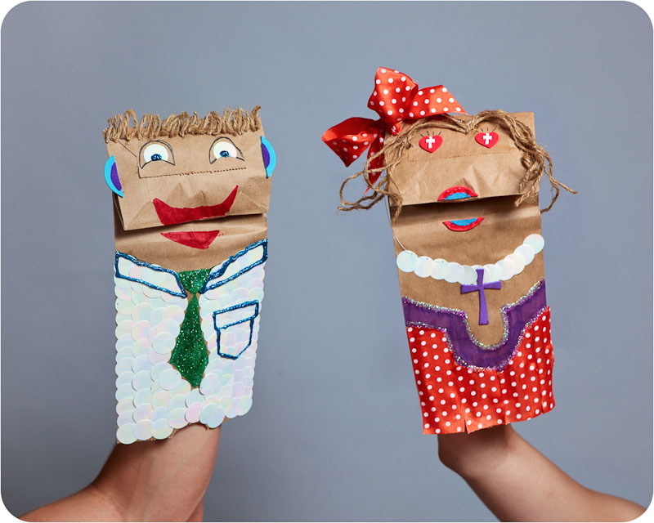

Illuminated letter name plate: Make an illuminated letter and use it on your name plate. This will help the viewer know who your puppet is. For example, if you’re reading about the monk, the “M” will be illuminated and the other letters will be written in bold font. There will be an opportunity for the class to create a backdrop that all puppets will present in front of.
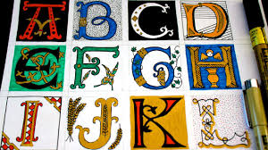

Poetry Reading: You will rehearse your section of the poem so you can read it smoothly. Remember to speak clearly and add intonation, so the audience stays interested in what you have to say. Some of the words are not used today so please feel free to have fun with reading them out loud.

Video Recording: When filming your puppet make sure you frame your video well. Use a tripod to minimize any shaking of the camera. We will review specific instructions for recording and editing when we are ready to film. Keep track of your iPad number.

Task | Name
Reader
Puppet Maker
Illuminated Letter Name Plate
Videographer
Editor
Research (One source each)

Additional Information:
- Where does your character fit in the social structure that existed during the Middle ages? Answer using complete sentences (3 marks)
- Write a 1-page journal entry from your character’s perspective that captures a day in their life. YOU WILL BE REQUIRED TO DO ADDITIONAL REASEARCH ON YOUR CHARACTER (at least 2 resources). Think about what they would do on a regular day, who they would interact with, what they would eat or life problems they would face. Remember to use imagery in your writing (sound, sight, scent, taste and touch) (16 marks)
- Create research notes and a bibliography using APA formatting to show where you found your information. (10 marks)

